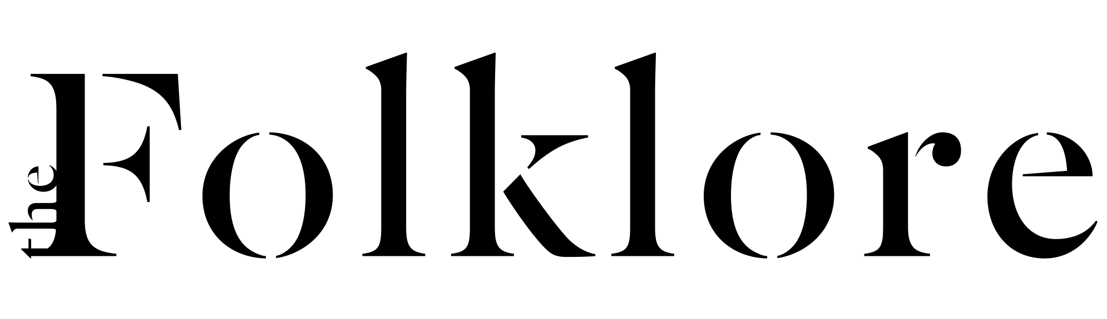

Product Concept Brief Template (Apparel)

[Your logo]

[Your Company Name]

[Company Address]

[Company Phone Number]

Prepared by:

[Your Name], [Your Role]   
[Your Email]

Product overview

**Product Name:** The proposed name of the product.

**Description**: A brief description of the product, including its primary function and unique selling points.

**Purpose**: The main goal or problem the product aims to solve.

Target market

**Demographics**: Age, gender, income level and other relevant characteristics of the intended audience.

**Psychographics**: Lifestyle, values and interests of the target market.

**User needs**: What unmet needs or frustrations does this product address?

Product design and features

**Design and aesthetic**: Visual style, colors, shapes, and overall look of the product, from style (dressy, casual, athleisure etc) to key elements (silhouette, neckline etc).

**Functional specifications**: Key features and functionalities the product must have such as pockets, fastenings, adjustable straps, wrinkle-resistant fabric etc).

**Size and dimensions**: Detailed measurements and proportions.

Materials and components

**Material requirements**: Types of materials to be used (textiles, metals, etc).

**Sourcing**: Preferred suppliers or regions for sourcing materials.

Manufacturing process

**Production techniques**: Specific manufacturing methods to be used such as machine sewing, knitting or handcrafting.

**Quality standards**: Expected quality levels and testing requirements.

**Packaging**: Specifications for how the product will be packaged.

Budget and timeline

**Cost estimates**: Preliminary budget for production, including materials and labor.

**Timeline**: Key milestones and deadlines from development to launch.

**Pricing**: Proposed retail price range that aligns with your target market and brand positioning.

**Seasonality**: Specify the collection that the product will be part of (fall/winter, spring/summer, resort, year-round).

Mood board

Create a collage of images that convey the aesthetic or inspiration for the product.

Consider:

* Color palette
* Textures and patterns
* Styling inspiration
* Target customer lifestyle imagery

Additional considerations:

* Potential variants: Could this concept work in other colors or lengths?
* Marketing angles: Preliminary ideas on how to highlight the product’s best features.
* Competitor analysis: Brief notes on similar items and how yours differs.